**2)** **Write a blog on Difference between HTTP1.1 vs HTTP2**

**HTTP:**

The Hypertext Transfer Protocol (HTTP) is an application protocol that is, currently, **the foundation** of data communication for the World Wide Web.

HTTP (Hypertext Transfer Protocol) is a set of rules that runs on top of the TCP/IP suite of protocols and defines how files are to be transferred between clients and servers on the world wide web.

**HTTP1.1:**

Developed by Timothy Berners-Lee in 1989 as a communication standard for the World Wide Web, HTTP is a top-level application protocol that exchanges information between a client computer and a local or remote web server. In this process, a client sends a text-based request to a server by calling a method like GET or POST. In response, the server sends a resource like an HTML page back to the client

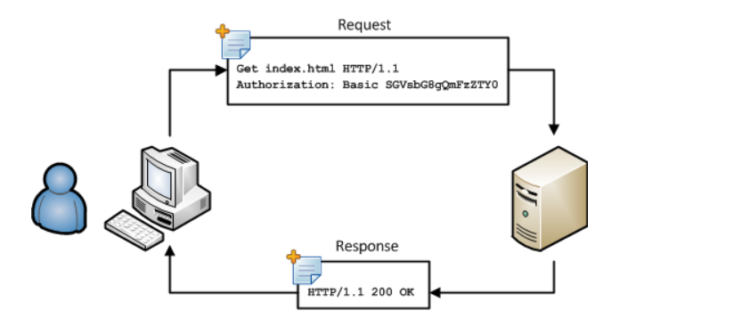

A simple and abstract example would be a **restaurant guest and a waiter**. The guest (**Client**) asks (**sends** **request**) waiter (**Server**) for a meal, then the waiter gets the meal from the restaurant chef (**your application logic**) and brings the meal to the guest.

**Key Features of HTTP/1.1:**

* It was no longer required for each connection to be terminated immediately after every request was served with a response; instead, with the keep-alive header, it was possible to have persistent connections. It allowed multiple requests/responses per TCP connection.

* The Upgrade header was used to indicate a preference from the client that made it possible to switch to a more preferred protocol if found appropriate by the server.

**HTTP2:**

At the beginning of 2010, Google introduced an experimental protocol, SPDY, which supported multiplexing (multiple requests/responses sent and received asynchronously over a single TCP connection) but as it gained traction IETF’s HTTP Working Group came up with HTTP/2 in 2015, which is based on the SPDY protocol.

HTTP/2 can send **multiple requests** for data in parallel over a **single** TCP connection. This is **the most advanced feature** of the HTTP/2 protocol because it **allows you to download web files asynchronously from one server**. Most modern browsers limit TCP connections to one server.

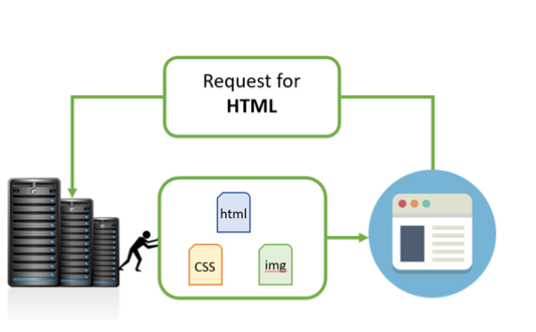

## Key Features of HTTP/2:

* It introduces the concept of a server push where the server anticipates the resources that will be required by the client and pushes them prior to the client making requests. The client retains the authority to deny the server push; however, in most cases, this feature adds a lot of efficiency to the process.
* Introduces the concept of multiplexing that interleaves the requests and responses without head-of-line blocking and does so over a single TCP connection.

**The table below points out the differentiating factors between http2 vs http1:**

|  |  |  |
| --- | --- | --- |
| Differentiator | HTTP1.1 | HTTP2 |
| Key Features | It supports connection reuse i.e. for every TCP connection there could be multiple requests and responses, and pipelining where the client can request several resources from the server at once. However, pipelining was hard to implement due to issues such as head-of-line blocking and was not a feasible solution. | Uses multiplexing, where over a single TCP connection resources to be delivered are interleaved and arrive at the client almost at the same time. It is done using streams which can be prioritized, can have dependencies and individual flow control. It also provides a feature called server push that allows the server to send data that the client will need but has not yet requested. |
| Status Code | Introduces a warning header field to carry additional information about the status of a message. Can define 24 status codes, error reporting is quicker and more efficient. | Underlying semantics of HTTP such as headers, status codes remains the same. |
| Web Traffic | HTTP/1.1 provides faster delivery of web pages and reduces web traffic as compared to HTTP/1.0. However, TCP starts slowly and with domain sharding (resources can be downloaded simultaneously by using multiple domains), connection reuse and pipelining, there is an increased risk of network congestion. | HTTP/2 utilizes multiplexing and server push to effectively reduce the page load time by a greater margin along with being less sensitive to network delays. |